CMPE679: Deep Learning
Homework 4
Adversarial Attacks and Model Robustness on CIFAR-10

Gloria Mbaka
Performed: 3/22/2026
Submitted: 3/22/2026

Instructor: Dr. Liu, Dongfang
TA: Huang, Renzhong and Renjen, Ishan

By submitting this report, I attest that I neither have given nor have received any unauthorized assistance (including writing, collecting data, plotting figures, tables, or graphs, or using previous student reports as a reference), and I further acknowledge that giving or receiving such assistance will result in a failing grade for this course.
Your Signature: | CGM

Abstract
This homework investigated the robustness of a pretrained CIFAR-10 image classifier to gradient-based adversarial perturbations. The assignment required non-targeted attacks under an L-infinity constraint with fixed perturbation magnitude ε = 8, together with black-box transfer attacks generated on proxy networks. A pretrained ResNet-110 model served as the target classifier. Four attack settings were evaluated: white-box Fast Gradient Sign Method (FGSM), white-box Iterative Fast Gradient Sign Method (I-FGSM), black-box FGSM using a proxy model, and ensemble black-box I-FGSM using multiple proxy models. The benign classifier achieved 95.0% accuracy with loss 0.22660. Under FGSM, accuracy dropped to 59.0% with loss 2.44207. Under I-FGSM, accuracy collapsed to 4.0% with loss 12.14075, indicating that iterative perturbations were substantially more destructive than one-step perturbations. In the black-box setting, FGSM reduced target-model accuracy to 65.0%, while ensemble black-box I-FGSM reduced it further to 13.0%. These results show that the target model is highly vulnerable in the white-box setting and remains meaningfully vulnerable even in the transfer-based black-box setting. The experiments therefore highlight both the effectiveness of iterative attacks and the practical risk posed by transferable adversarial examples.

1. Introduction
Deep neural networks achieve strong performance on benchmark image classification tasks, but their predictions can be destabilized by carefully designed perturbations that are nearly imperceptible to human observers. These perturbations are known as adversarial examples. Rather than changing the model parameters, adversarial attacks manipulate the input itself so that a classifier with fixed weights produces an incorrect prediction. As emphasized in the class attack lecture, the attack process can be formulated as input-space optimization under a norm constraint, and even black-box attacks are possible through transfer from surrogate or proxy models.
This homework focused on non-targeted adversarial attacks for CIFAR-10 classification. In a non-targeted attack, the goal is not to force one specific incorrect class, but rather to cause the classifier to predict any label other than the correct one. The assignment required three core attack families: FGSM, I-FGSM, and model ensemble attack, all under a fixed L-infinity constraint with ε = 8. The instructions also required a black-box setting in which the attack is carried out on a proxy network and then transferred to the target classifier.
The central question addressed in this report is: how much does classification performance degrade under single-step, iterative, and transfer-based adversarial attacks, and how does attack strength change as the attacker gains more optimization power or uses model ensembles to improve transferability? To answer this question, the report presents the mathematical formulation of the task, documents the implementation choices, and analyzes the experimental outcomes using model accuracy.

2. Dataset and Problem Definition

2.1 CIFAR-10 Data
The homework used a subset of CIFAR-10 consisting of 200 RGB images, with 20 images drawn from each of the 10 classes: airplane, automobile, bird, cat, deer, dog, frog, horse, ship, and truck. Each image has spatial size 32 × 32 and 3 color channels. The instructions specify this exact format and note that pretrained CIFAR-10 models from pytorchcv may be used as attack targets and proxies.
Let an input image be denoted by
$$x ∈ R^{3×32×32}$$
and let the true class label be
$$y ∈ \{0, 1, …, 9\}.$$
The pretrained target classifier maps x to a vector of logits z, from which the predicted class is obtained by selecting the maximum logit:
$$z = f(x),$$
$$ŷ =\underset{k}{argmax} z_{k}.$$

2.2 Non-Targeted Adversarial Objective
The assignment specifies a non-targeted attack objective. In this setting, an attack succeeds if the adversarial example is classified as any incorrect label. Therefore, given a benign image x, the goal is to construct a perturbed image x_adv such that the predicted class changes while the perturbation remains small:
$$x_{adv}= x + δ,$$
$$f\left(x_{adv}\right)≠ y.$$
The perturbation is constrained using the L-infinity norm:
||δ||_∞ ≤ ε.
In this homework, ε is fixed at 8 in the pixel-value convention. Because the implementation operates on normalized tensor inputs, the perturbation must be converted to the corresponding scaled value before being applied in tensor space. The key point remains unchanged: no pixel may change by more than ε under the L-infinity attack budget.

3. Model Architecture and Threat Setting

3.1 Target Model
The target classifier was a pretrained ResNet-110 model for CIFAR-10. ResNet architectures rely on residual connections to enable deep representation learning without the severe optimization problems that affect plain very-deep networks. Thus, in this homework, the model parameters remained fixed throughout the attack process. This is essential, because adversarial attacks operate by updating the input rather than retraining the model.
Given the model output logits
$$z ∈ R^{10},$$
class probabilities are computed by softmax:
$$p_{k}= \frac{\exp\left(z_{k}\right)}{Σ_{j}\exp\left(z_{j}\right)}.$$
The predicted class corresponds to the index of the largest probability or, equivalently, the largest logit.

3.2 White-Box and Black-Box Settings
Two threat settings were examined. In the white-box setting, gradients of the loss with respect to the input are computed directly through the target model. This gives the attacker full access to local gradient information and usually produces the strongest attacks. In the black-box setting, gradients are not taken through the target model. Instead, a proxy model is attacked, and the resulting adversarial examples are transferred to the target model. The attack lecture describes this exact schema: train or obtain a proxy network, generate attacked objects using the proxy, and then evaluate whether the perturbations transfer to the attacked target model.
This distinction matters because white-box results reveal the intrinsic vulnerability of the classifier under perfect attacker knowledge, whereas black-box transfer results reveal practical vulnerability when only surrogate information is available.

4. Attack Methodology

4.1 Loss Function
Cross-entropy loss was used to quantify classification error. For a true label y and predicted probability vector p, the loss is
$$L\left(x, y\right)= -\log\left(p_{y}\right).$$
In adversarial attack generation, the objective is to increase this loss with respect to the input x while keeping the classifier weights fixed. This is the opposite of standard training, where parameters are updated to decrease the loss.

4.2 Fast Gradient Sign Method (FGSM)
FGSM is a single-step gradient ascent attack. It computes the sign of the gradient of the loss with respect to the input and perturbs every input dimension in the direction that most rapidly increases the loss under an L-infinity constraint. The update is
$$x_{adv}= x + ε · sign\left(∇_{x}L\left(f\left(x\right), y\right)\right).$$
Because the perturbation is based on only one gradient evaluation, FGSM is computationally cheap and serves as a strong introductory baseline. The homework instructions explicitly require FGSM to be implemented from scratch rather than through a high-level adversarial-attack library.

4.3 Iterative Fast Gradient Sign Method (I-FGSM)
I-FGSM strengthens FGSM by replacing the single large step with multiple smaller steps. At iteration t, the current adversarial sample $x_{adv}^{t}$ is updated using
$$x_{adv}^{t+1}= x_{adv}^{t}+ α · sign\left(∇_{x}L\left(f\left(x_{adv}^{t}\right), y\right)\right).$$
After each update, the perturbation is projected back into the allowed L-infinity ball around the benign input and then clamped to the valid image range. This projection step prevents the perturbation from growing beyond the attack budget:
$$x_{adv}^{t+1}= clip\left(x_{adv}^{t+1}, x - ε, x + ε\right),$$
$$x_{adv}^{t+1}= clamp\left(x_{adv}^{t+1}, 0, 1\right).$$
Because I-FGSM repeatedly refines the attack direction, it is typically more powerful than FGSM. The homework describes I-FGSM as a medium baseline that should be stronger than simple FGSM.

4.4 Black-Box FGSM with Proxy Model
In the black-box FGSM experiment, a separate pretrained proxy network was used to generate the gradient-based perturbations. The attack itself still followed the FGSM formula, but the gradient was computed through the proxy rather than the target. The resulting adversarial images were then passed to the target ResNet-110 classifier. In this experiment, the selected proxy model was resnet56_cifar10.
If the target model misclassifies these transferred examples, then the attack demonstrates transferability. A black-box transfer attack is usually weaker than a white-box attack because the proxy gradient is only an approximation to the target gradient.

4.5 Ensemble Black-Box I-FGSM
To build a stronger black-box baseline, the homework asks for a model ensemble attack. In this setting, multiple proxy models are attacked simultaneously. The gradient directions from the proxies are combined, and iterative updates are applied using the aggregated gradient. Conceptually, if there are N proxy models, the ensemble gradient can be written as
$$g_{ensemble}= \left(\frac{1}{N}\right)Σ_{i}∇_{x}L\left(f_{i\left(x\right)}, y\right).$$
Using an ensemble improves transferability because perturbations that are effective across several proxy models are more likely to generalize to the unknown target classifier. This is labelled as the strong or boss baseline, which is consistent with the stronger performance observed in the results.

5. Evaluation Methodology
All settings were compared by measuring the fraction of correctly classified examples under each condition.
$Accuracy = \frac{Number of Correct Predictions}{Total Number of Samples}$.
Although loss values were also recorded to help interpret attack strength, the primary metric for comparison was accuracy. The experiments therefore considered five evaluation settings:
• Benign evaluation on clean images.
• White-box FGSM evaluation on adversarial images generated directly on the target model.
• White-box I-FGSM evaluation on adversarial images generated directly on the target model.
• Black-box FGSM evaluation on target-model predictions for proxy-generated adversarial images.
• Ensemble black-box I-FGSM evaluation on target-model predictions for ensemble-generated adversarial images.

6. Results and Visualization

6.1 Quantitative Results
Table 1 summarizes the measured accuracies and losses for benign images and all attack settings. The benign result confirms that the pretrained target model is strong on clean data, achieving 95.0% accuracy with low cross-entropy loss. This establishes a reliable baseline and shows that the model is not weak in the absence of perturbations. Consequently, the reductions observed under attack are not due to poor benign performance, but to genuine adversarial vulnerability.

Table 1: Accuracy and loss under benign and adversarial settings.
Setting | Accuracy | Loss
Benign | 0.95000 | 0.22660
FGSM | 0.59000 | 2.44207
I-FGSM | 0.04000 | 12.14075
Proxy FGSM on proxy model | 0.56500 | 2.45842
Black-box FGSM on target model | 0.65000 | 1.91246
Ensemble black-box I-FGSM on target | 0.13000 | 7.16737

6.2 FGSM Results
Under white-box FGSM, target-model accuracy fell from 95.0% to 59.0%, while loss rose from 0.22660 to 2.44207. This is a substantial degradation for a single-step attack. The result confirms that even one gradient-sign update is enough to produce many misclassifications. Figure 1 also shows that the perturbed images remain visually close to their benign counterparts even when the predicted class changes. For example, the FGSM visualization includes class changes such as airplane to bird and automobile to cat while preserving the overall visual appearance of the original objects.

6.3 I-FGSM Results
I-FGSM reduced target-model accuracy to 4.0% and increased loss to 12.14075. This result is dramatically stronger than FGSM and is entirely consistent with the expected behavior of iterative attacks. The gap between FGSM and I-FGSM shows that repeated constrained updates allow the attacker to refine the perturbation direction much more effectively than a single-step approximation. The near-collapse of accuracy indicates that the target model is extremely non-robust in the white-box setting. Figure 2 shows the Benign and I-FGSM examples.

6.4 Black-Box FGSM Results
The chosen proxy model for black-box FGSM was resnet56_cifar10. On the proxy itself, FGSM reduced accuracy to 56.5% with loss 2.45842, confirming that the attack was successful on the surrogate. When those same adversarial examples were transferred to the target model, target accuracy became 65.0% with loss 1.91246. This is weaker than white-box FGSM on the target, which produced 59.0% accuracy. That ordering is expected because transfer attacks do not use the exact target gradient. Nevertheless, the drop from 95.0% to 65.0% still demonstrates meaningful transferability. Figure 3 shows the Benign and black-box FGSM examples.
6.5 Ensemble Black-Box I-FGSM Results
The ensemble black-box I-FGSM attack reduced target-model accuracy to 13.0% with loss 7.16737. This is much stronger than simple black-box FGSM and shows that combining multiple proxy gradients significantly improves transfer strength. Although this attack remains weaker than full white-box I-FGSM, it demonstrates that an attacker can achieve severe accuracy degradation without direct access to the target model parameters. Figure 4 shows the Benign and ensemble black-box I-FGSM examples.
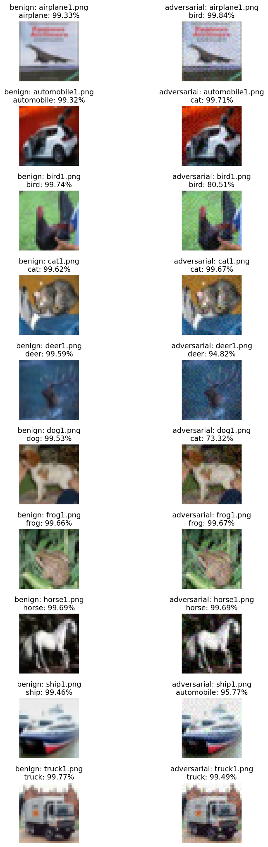
Figure 1: Benign and FGSM examples. The paired images show that small perturbations can induce major prediction changes while preserving overall perceptual appearance.
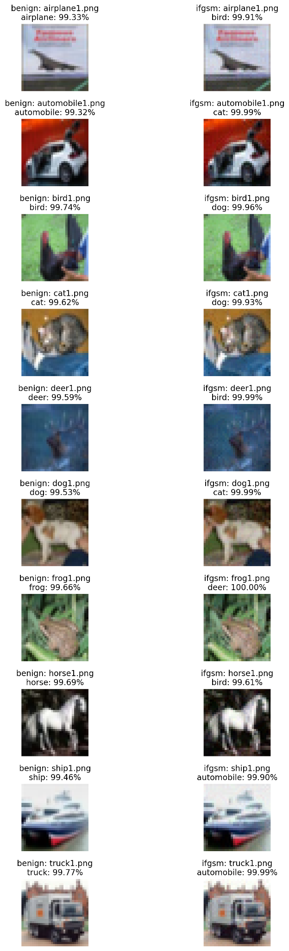
Figure 2: Benign and I-FGSM examples. Compared with FGSM, I-FGSM produces more consistently successful class changes, reflecting the greater strength of iterative optimization.
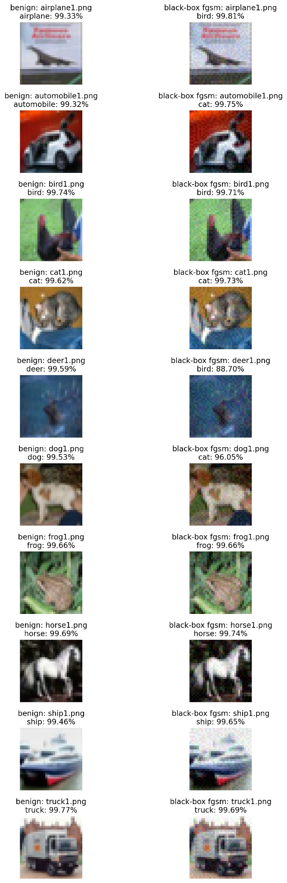
Figure 3: Benign and black-box FGSM examples. These results demonstrate transferability: adversarial examples generated on a proxy model can still fool the target model.
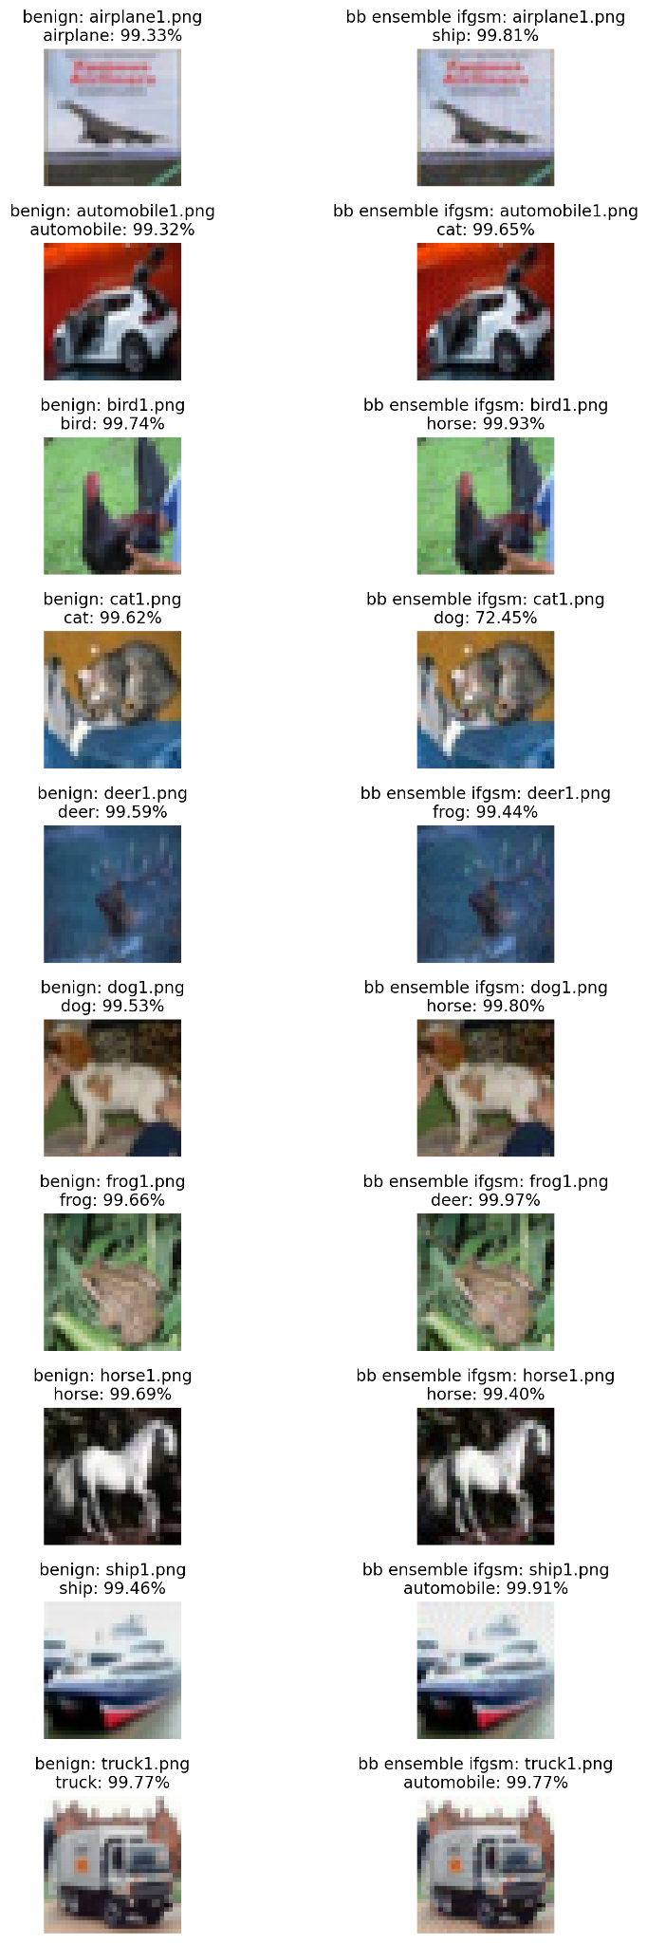
Figure 4: Benign and ensemble black-box I-FGSM examples. The ensemble surrogate attack produces stronger transfer and more frequent label changes than simple black-box FGSM.

7. Discussion and Lessons Learned
Several clear patterns emerge from the experiments. First, iterative attacks are much stronger than single-step attacks. The transition from FGSM accuracy 0.59000 to I-FGSM accuracy 0.04000 shows that the target model is highly vulnerable once the attacker is allowed to iteratively refine the perturbation. This aligns with the attack lecture, which presents iterative FGSM as a stronger extension of FGSM under the same L-infinity threat model.
Second, black-box attacks are weaker than white-box attacks, but still dangerous. The black-box FGSM result of 0.65000 accuracy is not as strong as the white-box FGSM result of 0.59000 accuracy. This is a natural outcome of transfer-based attacks, since the proxy gradient does not perfectly match the target gradient. However, the fact that accuracy still dropped by 30 percentage points confirms that transferable adversarial examples are a real threat rather than a theoretical curiosity.
Third, model ensembles improve black-box attack strength. The ensemble black-box I-FGSM result of 0.13000 accuracy is dramatically stronger than simple black-box FGSM. This means that combining proxy gradients yields perturbations that generalize more effectively across models. From a security perspective, this is especially important because it shows that attackers do not need exact knowledge of the target network to generate highly destructive adversarial inputs.
A useful way to rank the attack settings from weakest to strongest, in terms of their effect on target-model accuracy, is as follows:
Benign > Black-box FGSM > FGSM > Ensemble Black-box I-FGSM > I-FGSM.
This ordering is coherent and supports the correctness of the implementation. It also provides a compact summary of the threat landscape: benign performance is high, single-step attacks are already harmful, iterative attacks are much stronger, and black-box ensembles bridge a substantial part of the gap between simple transfer attacks and full white-box access.

8. Conclusion
This homework provided a hands-on study of adversarial vulnerability in deep image classifiers. A pretrained ResNet-110 model for CIFAR-10 was evaluated under white-box FGSM, white-box I-FGSM, black-box FGSM using a proxy network, and ensemble black-box I-FGSM. The results showed a clear and consistent pattern. The benign classifier was strong, but its performance degraded sharply under attack. FGSM reduced accuracy to 59.0%, I-FGSM nearly collapsed it to 4.0%, black-box FGSM reduced it to 65.0%, and ensemble black-box I-FGSM pushed it down further to 13.0%.
Overall, the experiments demonstrate that adversarial robustness cannot be inferred from benign accuracy alone. A model that performs well on clean images may still be highly fragile under input-space perturbations. The results also reinforce the practical importance of transferability and ensemble-based attacks in black-box scenarios.

9. AI Usage Disclosure
Artificial intelligence tools were used to clarify theoretical concepts, assist with debugging, and refine report organization. All experiments, code implementations, visualizations, and numerical results were generated independently by me. AI assistance was limited to conceptual guidance and editorial refinement.

References
[1] I. Goodfellow, J. Shlens, and C. Szegedy, “Explaining and Harnessing Adversarial Examples,” International Conference on Learning Representations (ICLR), 2015.
[2] A. Kurakin, I. Goodfellow, and S. Bengio, “Adversarial Examples in the Physical World,” arXiv preprint arXiv:1607.02533, 2017.
[3] A. Madry, A. Makelov, L. Schmidt, D. Tsipras, and A. Vladu, “Towards Deep Learning Models Resistant to Adversarial Attacks,” International Conference on Learning Representations (ICLR), 2018.
[4] A. Paszke et al., “PyTorch: An Imperative Style, High-Performance Deep Learning Library,” Advances in Neural Information Processing Systems (NeurIPS), vol. 32, 2019.
[5] “Homework 4 Instructions,” CMPE679 Deep Learning, Rochester Institute of Technology, 2026.
[6] “Attack Lecture Notes,” CMPE679 Deep Learning, Rochester Institute of Technology, 2026.

